Contents
Basics: 1
Variables 1
Template Literal 2
Pop Up Boxes 2
Global Methods 2
Document Object Model 2
Style 2
Events 3
Strings 3
Math 3
Date 3
Arrays 3
Array of Objects 4
JavaScript Templates 4
Handlebars 4

JavaScript is used for the functionality of a website.

Basics:
- All inside script tag.
- All statements end with a ; (optional but good practice)

Variables
- Declared with “let variable = value” (changeable) or “const variable = value” (constant)
- Types (Numeric, String, Boolean, Object, Undefined)
- typeof(variable) checks type.

Template Literal
- A string that is inside ``, used instead of string concatenation.
- ${value} to add variable.
Pop Up Boxes
- “alert” makes a pop up box appear with just ok.
- “confirm” makes okay or cancel appear. If “ok” result is true.
- “prompt” asks for user input. “cancel” returns null.

Global Methods
- isNaN(value) returns true if value isn’t a number and false if it is.
- parseInt(string) turns string into an integer as far as it is valid, if impossible NaN is returned.
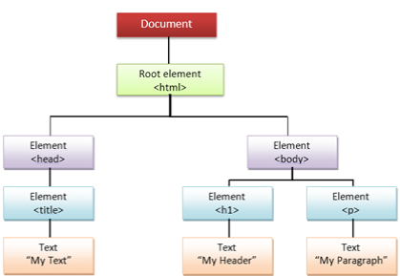
- parseFloat(string) same as above but turns it into a float.

Document Object Model
- Representation of the objects that structure the page.
- Tree like structure.
- Document at the top, then elements such as “h1”, and then text nodes.

Style
- Use “.querySelector” to access specific elements, used to attribute CSS to specific parts of the page.
- “.classList.add(‘name’) add class to an element. Can toggle and remove also.
- “.className” replaces existing classes with new one.
- “.textContent” changes the text of an element.
- “.innerHTML” changes the HTML of an element.

Events
- “.addEventListener(click, (evt) function)” will cause the function to occur when element is clicked.

Strings
- “string.length” returns length of the string.
- “string.toUpper/LowerCase()” turns string into all upper/lower case.
- “charAt(n)” returns character at index n.
- “substring(1, 3)” returns characters from index 1 and 2.
- “indexOf(search, n)” returns index of searches starting at n.
- “split( )” splits the string at every value inside brackets.
- “toString()” converts input to a string.

Math
- “sqrt(x)” find the square root of x.
- “pow(x, y)” returns x to the power of y.
- “round(x)” rounds x.
- “floor(x)” rounds x down.
- “ceil(x)” rounds x up.
- “min/max(x, y)” returns the smaller/bigger number.
- “random()” returns a random decimal between 0 and 1.

Date
- “let now = new Date()” create an empty date object.
- “getDate()” returns the day of the month.
- “getDay()” returns an integer representing the day of the week (Sunday = 0)
- “getMonth()” returns an integer representing the month (January = 0)
- “getFullYear()” returns the year.
- Others (getHours/getSeconds/getTime/getMinutes/getMilliseconds)

Arrays
- “let name = [“Jake”, “Kate”]” Creates Array
- Use loops to output individual elements of arrays.
- “join(‘,’)” puts elements into string and separates them with the character in brackets.
- “push()” add elements to end of array.
- “unshift()” add elements to start of array.
- “pop()” remove last element.
- “shift()” remove first element.
- “splice(n, 2)” delete 2 elements starting at index n.
- “splice(2, 0, new)” add value new at index 2.
- “sort()” sort elements in an array.
- “sort((a, b) => a> b ? 1 : -1)” sort elements by number.
- “findIndex(function)” checks elements that meet function, returns first that passes.
- “filter(function)” checks elements that meet function, makes new array with passes.
- “map(function)” creates a new array of values made by applying function to elements.
- “reduce()” applies a function to elements and returns the accumulated result.
- “…” splits the array into individual elements.

Objects
- Declared by “const name = { ‘1’ : ‘Josh’, ‘2’: ‘Sean’}” creates value pairs in an array.
- To call Josh use “name.1” .

Array of Objects
- An array filled with the objects above, separated by commas, using “{}” is good practice to make an obvious separation.
- Use forEach loop to cycle through each. Can print full cards or specific information about each object (employees maybe)

JavaScript Templates
- Used to separate HTML structure from content. Needed to update data on pages efficiently, makes page dynamic.
- Simple with some new syntax.

Handlebars
- A templating engine for JavaScript that allows you to add templates that will be parsed and interpolated (values of properties inserted in place) with the values from the data (JSON data) you passed to the Handlebars function.
Example:
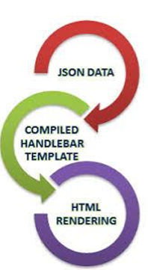
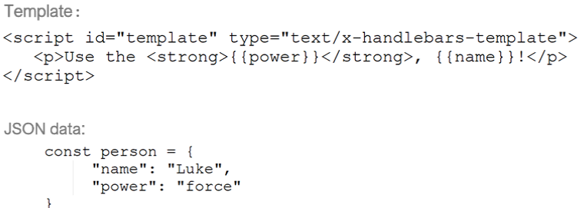
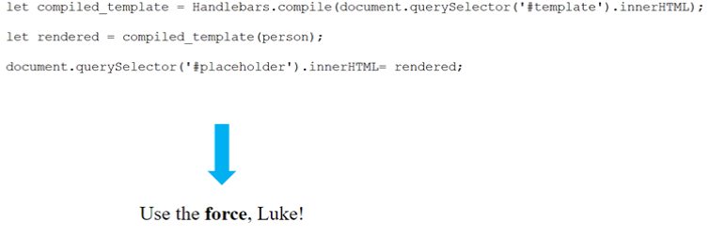
- A “context” is a JavaScript object added to a template.
- Each template script has an id and a type.
- Handlebars.compile is used to compile the template (Obtaining a JS object).
- You have to combine template and context to get HTML code (map template with object) “let rendered = compiled_template(objectName)”.

Handlebars Expressions
- “{{variable}}” a simple identifier used to insert value from the context.
- To add HTML attributes to it in the context “<bold>” use a triple stash {{{name}}} when calling it. This stops HTML escaping.

Handlebars Helps
- Each “{{#each variableName}} {{/each}}” iterates over values in an array. (Print each one for example).
- With “{{#with variableName}} {{/with}}” allows you to clarify which object your taking values from (stops you having to say “variableName.value” every time inside the with statement).
- If “{{#if countries}} …. {{else}} …. {{/if}}” used conditionally to only render code if argument isn’t equal to false, undefined, null or [].

